Monitoring Task

**Installing tomcat on windows:**

**Please Note !**

Tomcat doesn’t work without java, so before installing tomcat on the machine, you should install a compatible java runtime version and setup JAVA_HOME environment variable.

**Installation :**

* Download the windows service installer from [here](https://tomcat.apache.org/download-80.cgi).
* Install the downloaded file, pass all the setup until reaching Configuration Options:

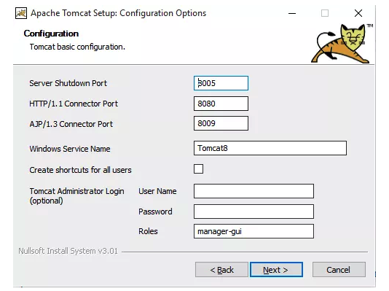

To change the default running port of tomcat, open “server.xml”

under conf folder and change the port attribute of Connector tag.

**Git configuration:**

**Create new repo in GitHub - tomcat application**

In your text editor, you will develop a simple JSP that creates a web page to display the current date. Type in the following statements in a new file:

<html>

<head><title>First JSP</title></head>

<body>

<%

double num = Math.random();

if (num > 0.95) {

%>

<h2>You'll have a luck day!</h2><p>(<%= num %>)</p>

<%

} else {

%>

<h2>Well, life goes on ... </h2><p>(<%= num %>)</p>

<%

}

%>

<a href="<%= request.getRequestURI() %>"><h3>Try Again</h3></a>

</body>

</html>

Save your file as Random.jsp.

Add **(add-> commit -> push)** the Date.jsp file (choose from web or create new) to your new repository .

**Jenkins configuration:**

**Ensure plugin - GitHub integration is installed**

**Create new job**

New item -> item name -> freestyle project

**Configure which Git Repositories to work with the jenkins:**

Source Code Management -> choose Git -> enter your URL

**Build Triggers:**

Choose Poll SCM -> in Schedule type * * * * * (every minute)

Now run your script

(the Jenkins job automatically pull the files from repo)

**Execute windows command:**

* Build -> Add build step -> Execute windows batch command -> create directory under your CATALINA_HOME/webapps/ROOT with your name (i.e c:/Program Files/Apache Software Foundation/Tomcat8.5/webapps/ROOT/Ziv_Vilozni)
* Build -> Add build step -> Execute windows batch command -> Copy your file to the new path

**Monitoring stage:**

* **Download monitor plugin from jenkins.**
* **Add monitor stage (in build stage or post build) to your Job (test your URL)**

**Jenkins with Git:**

**Change the JSP file name and replace with the new one (Add new commit).**

* **wait minute to the automatic build in Jenkins .**
* **Test again and check result (without change the url in test).**

**Finished– Great!!!**

1. Take a screenshot of your GITHUB Repository (showing your name)
2. Take a screenshot of your Jenkins Job (with success) and Jenkins Job

configuration

1. Take a screenshot of your Tomcat website (showing your URL)
2. Take a screenshot with the results from monitor (showing before and after the change)

Send it to [ziv.devops@gmail.com](mailto:ziv.devops@gmail.com)

(Email subject – Exercise 3 Monitoring)

**Deadline for submission: Till the lesson next week**